@prefix univ: <http://www.cs.ccsu.edu/~neli/univ.owl> .

@prefix xsd: <http://www.w3.org/2001/XMLSchema#> .

@prefix foaf: <http://xmlns.com/foaf/0.1/> .

@base <http://www.students.ccsu.edu/~kv1002/> .

@prefix ex: <http://example.org/> .

<#Student01>

a univ:Student;

univ:studentID 3035648;

foaf:name "Kino Rose"^^xsd:string;

univ:studies <http://www.cs.ccsu.edu/~neli/univ.owl#CS101>, <http://www.cs.ccsu.edu/~neli/univ.owl#CS102>, <http://www.cs.ccsu.edu/~neli/univ.owl#Math101> .

<#Student02>

a univ:Student;

univ:studentID 3031999;

foaf:name "Oswald Cobblepot"^^xsd:string;

univ:studies <http://www.cs.ccsu.edu/~neli/univ.owl#CS101>, <http://www.cs.ccsu.edu/~neli/univ.owl#Math101> .

<#Student03>

a univ:Student;

univ:studentID 3032017;

foaf:name "James Fallon"^^xsd:string;

univ:studies <http://www.cs.ccsu.edu/~neli/univ.owl#Math101> .

<#Student04>

a univ:Student;

univ:studentID 30348655;

foaf:name "Matthew Krieger"^^xsd:string;

foaf:homepage <http://www.MatthewKrieger.com > ;

foaf:knows [ a foaf:Person ;

foaf:mbox\_sha1sum "31cbd24449b490be8997f4a7110513f98bcac498" ;

foaf:name "James Varitek "

] ;

foaf:knows [ a foaf:Person ;

foaf:mbox\_sha1sum "8855c1b43c2f194d3468910d685ae0167b7b2604" ;

foaf:name "Keith Reagan"

] ;

foaf:knows [ a foaf:Person ;

foaf:mbox\_sha1sum "4852038eeaa0b04a43745ca10398382f5e06b137" ;

foaf:name "Kevin Smith"

] ;

foaf:mbox\_sha1sum "5941a4e46ae418d310741cc93a969e8c2d3d9085" ;

univ:studies <http://www.cs.ccsu.edu/~neli/univ.owl#CS101>, <http://www.cs.ccsu.edu/~neli/univ.owl#CS102>, <http://www.cs.ccsu.edu/~neli/univ.owl#Math101> .

<#Student05>

a univ:Student;

univ:studentID 7895;

foaf:name "Harini Venkat"^^xsd:string;

univ:studies <http://www.cs.ccsu.edu/~neli/univ.owl#CS101> .

<#Student06>

a univ:Student;

univ:studentID 0001;

foaf:name "Jane Cyrus"^^xsd:string;

univ:studies <http://www.cs.ccsu.edu/~neli/univ.owl#Math101> .

<#Student07>

a univ:Student;

univ:studentID 0002;

foaf:name "Sarah Jane"^^xsd:string .

<#Student08>

a univ:Student;

univ:studentID 0003;

foaf:name "Jeff Barr"^^xsd:string .

<#Student09>

a univ:Student;

univ:studentID 0004;

foaf:name "Saranya Lingam"^^xsd:string;

univ:studies <http://www.cs.ccsu.edu/~neli/univ.owl#CS101>, <http://www.cs.ccsu.edu/~neli/univ.owl#CS102>, <http://www.cs.ccsu.edu/~neli/univ.owl#Math101> .

<#Student10>

a univ:Student;

univ:studentID 0005;

foaf:name "Harish Kumar"^^xsd:string;

univ:studies <http://www.cs.ccsu.edu/~neli/univ.owl#CS101> .

<#Professor01>

a univ:Lecturer;

univ:staffID 2345;

foaf:name "Bob Jones"^^xsd:string ;

univ:teaches <http://www.cs.ccsu.edu/~neli/univ.owl#Math101> .

<#Professor02>

a univ:Lecturer;

univ:staffID 3498;

foaf:name "Neli Zlaterava"^^xsd:string ;

univ:teaches <http://www.cs.ccsu.edu/~neli/univ.owl#CS102> .

<#Professor03>

a univ:Lecturer;

univ:staffID 8978;

foaf:name "Chad Williams"^^xsd:string;

univ:teaches <http://www.cs.ccsu.edu/~neli/univ.owl#CS101> .

<#Math101>

a univ:MathModule;

ex:textbook <http://www.students.ccsu.edu/~kv1002/#978-0133507164>;

ex:textbook <http://www.students.ccsu.edu/~kv1002/#978-1285860268> .

<#CS102>

a univ:MathModule .

<#CS101>

a univ:CSModule;

ex:textbook <http://www.students.ccsu.edu/~kv1002/978-0131103627> .

<#978-0131103627>

a ex:textbook .

<#978-0133507164>

a ex:textbook .

<#978-1285860268>

a ex:textbook .

1. Use Fuseki or ARQ to generate

5 different SELECT queries:

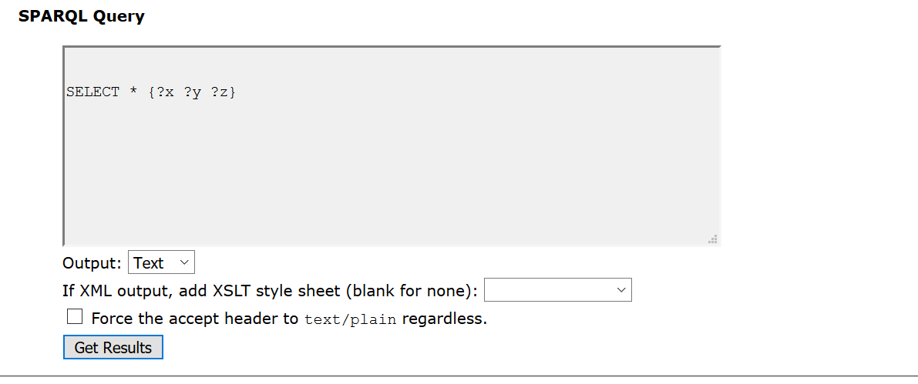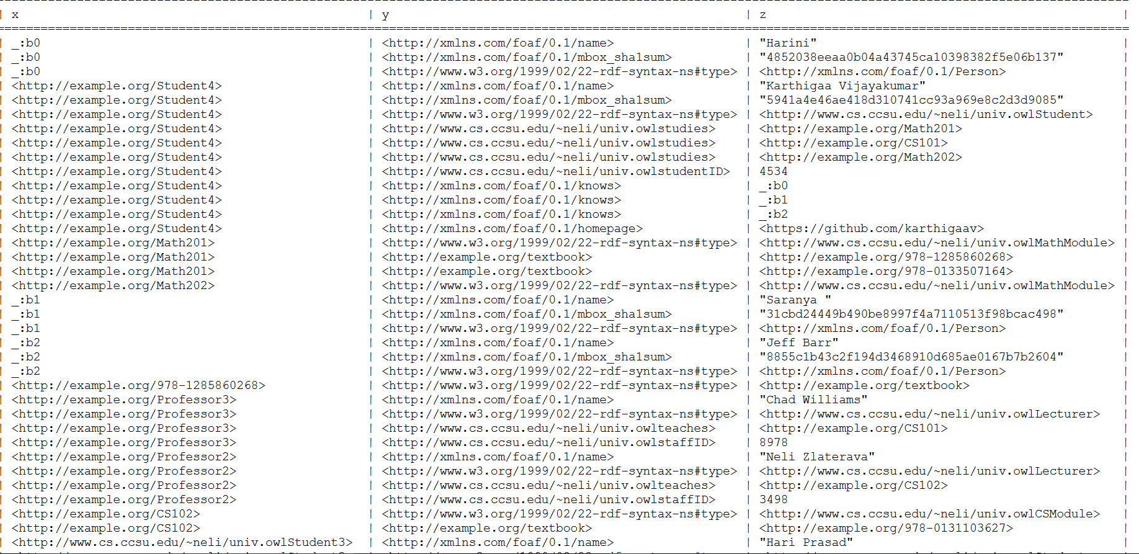

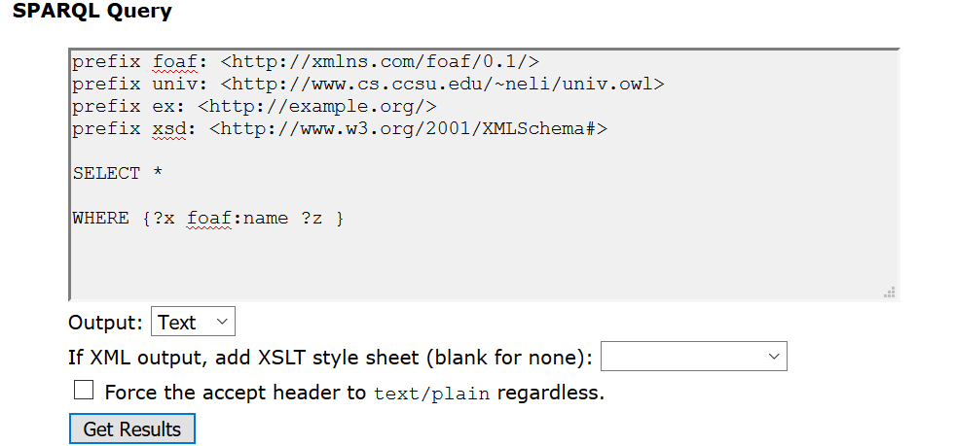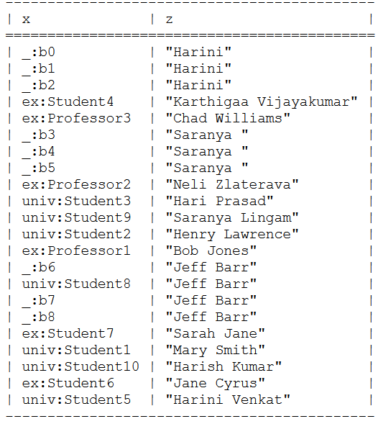

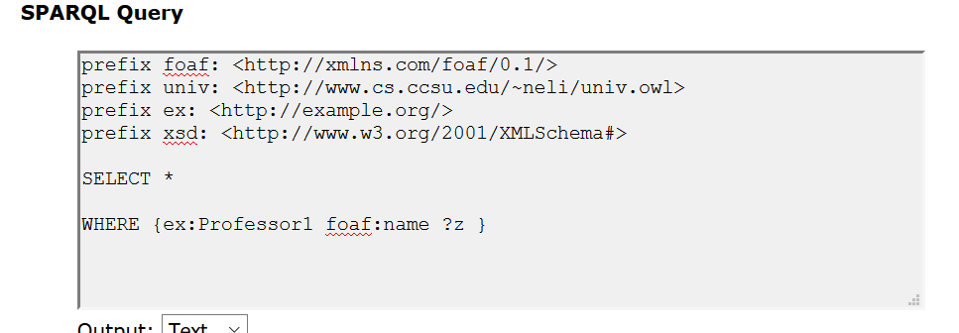

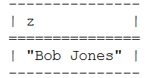

2 different ASK queries,

1 DESCRIBE query, and

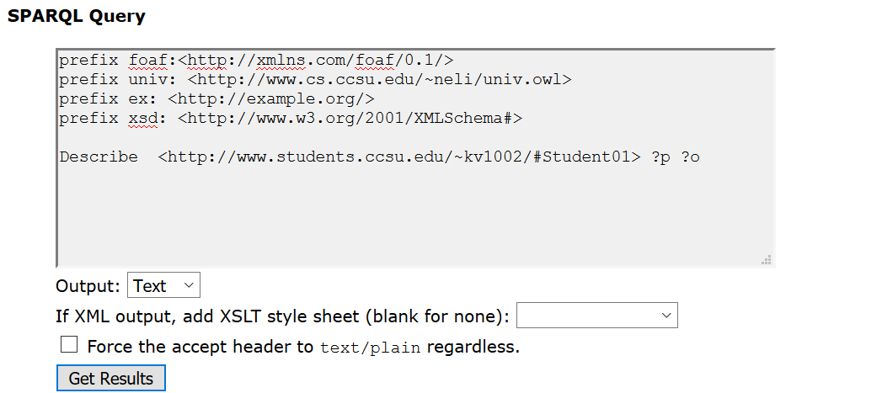

Output:

@prefix univ: <http://www.cs.ccsu.edu/~neli/univ.owl> .

@prefix ex: <http://example.org/> .

@prefix xsd: <http://www.w3.org/2001/XMLSchema#> .

@prefix foaf: <http://xmlns.com/foaf/0.1/> .

<http://www.students.ccsu.edu/~kv1002/#Student01>

a univ:Student ;

univ:studentID 4567 ;

univ:studies <http://www.students.ccsu.edu/~kv1002/#Math201> , <http://www.students.ccsu.edu/~kv1002/#CS101> , <http://www.students.ccsu.edu/~kv1002/#Math202> ;

foaf:name "Mary Smith" .

1 construct query.

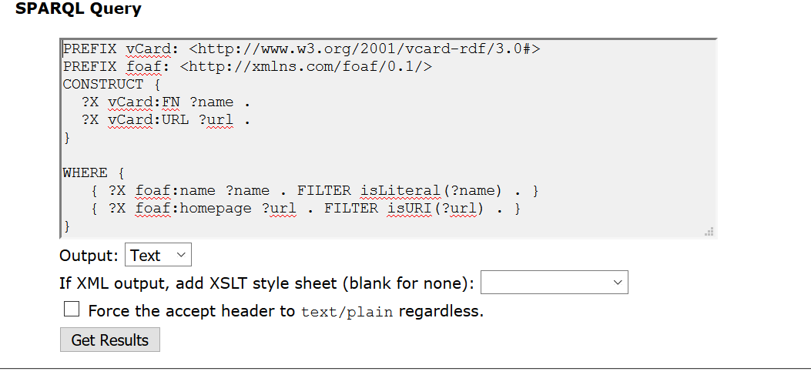

@prefix univ: <http://www.cs.ccsu.edu/~neli/univ.owl> .

@prefix ex: <http://example.org/> .

@prefix vCard: <http://www.w3.org/2001/vcard-rdf/3.0#> .

@prefix xsd: <http://www.w3.org/2001/XMLSchema#> .

@prefix foaf: <http://xmlns.com/foaf/0.1/> .

<http://example/upload-base/#Student04>

vCard:FN "Karthigaa Vijayakumar" ;

vCard:URL <https://github.com/karthigaav> .

ex:Student4 vCard:FN "Karthigaa Vijayakumar" ;

vCard:URL <https://github.com/karthigaav> .

<http://www.students.ccsu.edu/~kv1002/#Student04>

vCard:FN "Karthigaa Vijayakumar" ;

vCard:URL <https://github.com/karthigaav> .

Ask queries:

R_Ask2.PNG

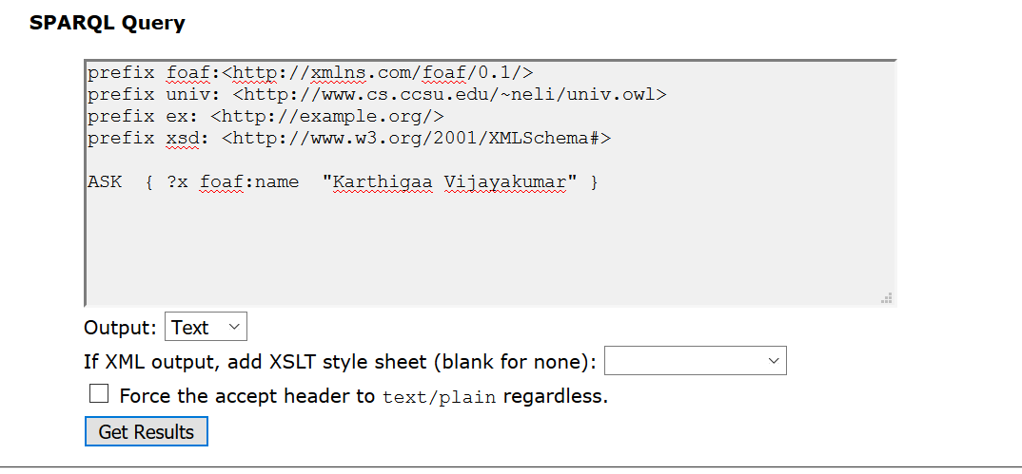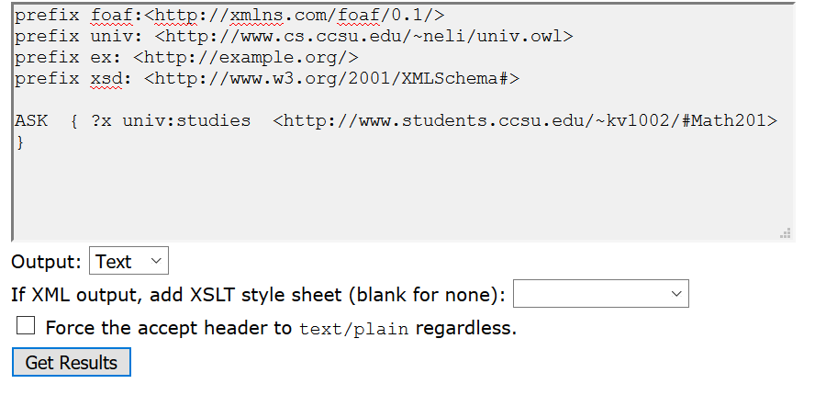

r_Ask1.PNG